**SQL Assignment -3**

* Retrieve data using Group By clause

Sample table1:Department

-dept_id

-dept_name

Sample table2: Employee

-emp_id

-dept_id

-mngr_id

-emp_name

-salary

create table Department(

dept_id int NOT NULL Primary key,

dept_name varchar(40) NOT NULL

)

create table Employee(

emp_id int NOT NULL Primary key,

dept_id int FOREIGN KEY REFERENCES Department(dept_id),

mngr_id int ,

emp_name varchar(40) NOT NULL,

salary decimal(10,2) NOT NULL

)

insert into Department values('1','Administration')

insert into Department values('2','Research')

insert into Department values('3','Marketing')

insert into Department values('4','Sales')

insert into Department values('5','Human resources')

insert into Department values('6','Accounting')

insert into Department values('7','Finance')

insert into Employee values('100','4','1001','kailash','10000')

insert into Employee values('101','5','1002','manish','9900')

insert into Employee values('102','3','1003','archan','9000')

insert into Employee values('103','2','1004','darshan','7700')

insert into Employee values('104','6','1005','vivek','8000')

insert into Employee values('105','1','1006','ronak','7000')

insert into Employee values('106','7','1007','hiren','9500')

insert into Employee values('107','3','1008','tejas','9000')

insert into Employee values('108','1','1009','gaurav','10000')

insert into Employee values('109','6','1010','ketan','7500')

insert into Employee values('110','2','1011','hasu','8800')

insert into Employee values('111','7','1012','rakesh','9300')

insert into Employee values('112','5','1013','mehul','7900')

insert into Employee values('113','4','1014','rahul','6500')

select *from Department

select *from Employee

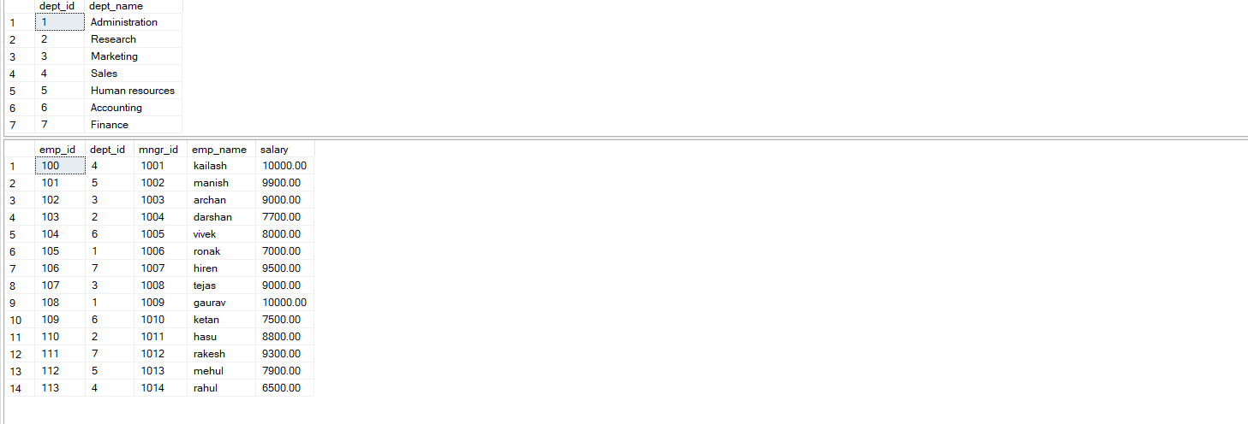

**1] write a SQL query to find Employees who have the biggest salary in their Department**

SELECT emp_id, emp_name, salary AS [MAX SALART], Employee.dept_id,

dept_name

FROM Employee

INNER JOIN Department ON Department.dept_id = Employee.dept_id

WHERE salary IN

(SELECT MAX(salary) From Employee GROUP BY dept_id)

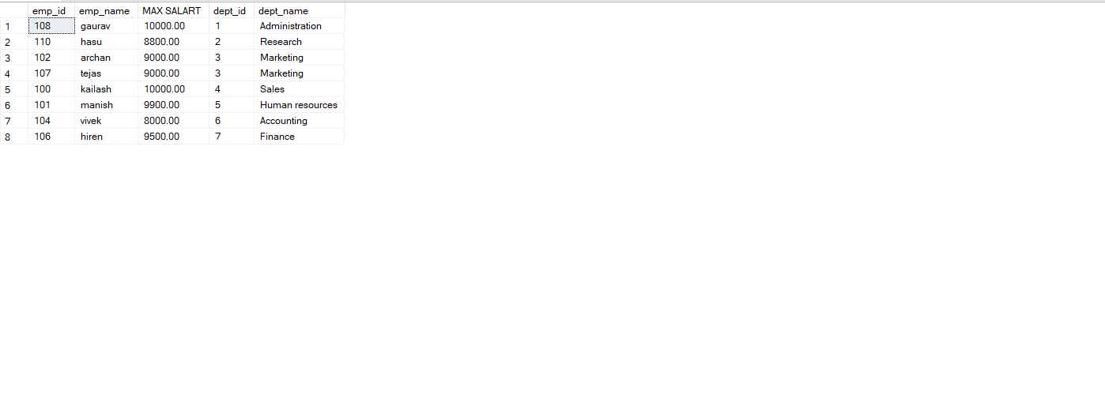

**2] write a SQL query to find Departments that have less than 3 people in it**

SELECT Department.dept_id,dept_name, COUNT(emp_id) AS Employees

FROM Department

JOIN Employee ON Employee.dept_id = Department.dept_id

GROUP BY dept_name, Department.dept_id

Having COUNT(emp_id) < 3



**3. write a SQL query to find All Department along with the number of people there**

SELECT Department.dept_name, COUNT(emp_id) AS [people in department]

FROM Employee

RIGHT JOIN Department ON Department.dept_id = Employee.dept_id

GROUP BY Department.dept_name

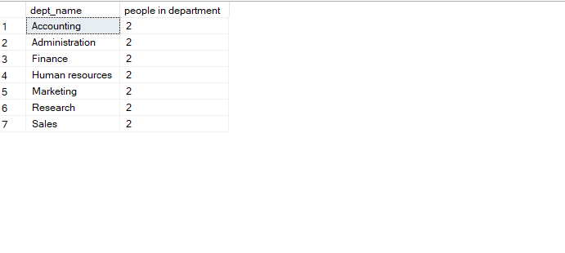**4. write a SQL query to find All Department along with the total salary there**

SELECT dept_name, Employee.dept_id, SUM(salary) AS [Total salary of department]

FROM Employee

RIGHT JOIN Department ON Employee.dept_id = Department.dept_id

GROUP BY dept_name,Employee.dept_id

